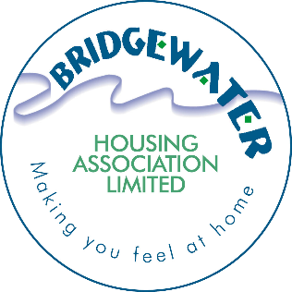

Bridgewater Housing Association Strategy
Policy name | Corporate Social Responsibility Strategy
Policy category | Corporate (Governance)
Policy number | CS67
Date adopted | 29 May 2024
Last review | New policy
This review | 29 May 2024
Next review | 29 May 2027
Equalities impact assessment required | No
Equalities impact assessment completed | n/a – not customer facing
Links to other documents | Employee Volunteering Policy  Customer Engagement Strategy
Consultation | Yes – internal with staff.
Need for Procedure | No
Policy Owner | Chief Executive

This strategy can also be provided in large print, braille, audio, or other non-written format and in a variety of languages on request. Please contact the Association by emailing admin@bridgewaterha.org.uk or call 0141 812 2237 to request this.

1. INTRODUCTION

1.1 The corporate vision of Bridgewater Housing Association is “A customer focussed organisation that delivers the best affordable housing and services to people who need them most.” and in doing this we have adopted our Bridge Values:
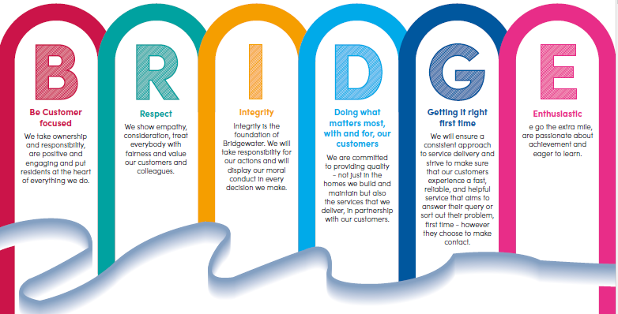

These values are detailed in our Business Plan for 2023 to 2028 and one of our key strategic priorities is to “Priority 23 - Develop our culture.”
1.2 This Strategy is about making a positive contribution and detailing how we are going to do it. We recognise our role as a key employer and community anchor within Erskine and Renfrewshire and as such we have responsibilities which go beyond the offices of the Association.

2. WHAT IS CORPORATE SOCIAL RESPONSIBILITY
2.1 Corporate Social Responsibility (CSR) refers to the efforts made by a company to improve society and contribute towards sustainable development. It is about companies “doing their bit” for society and goes beyond what is deemed compulsory by law and any of our regulatory standards. CSR can refer to one activity or various activities deployed by a business; for example, it can be about volunteering on its own or it can be about making an environmental and social impact as well as volunteering.
2.2 The Association’s Corporate Social Responsibility (CSR) Strategy focusses on the following core commitments –
- Employability
- Community Participation
- Environment and Protection
- Health and Wellbeing

3. CORPORATE SOCIAL RESPONSIBILITY BENEFITS
3.1 There are numerous benefits associated with CSR for the business and for our role within the community and the wider housing sector. Some examples of that are detailed below –
- Community Anchor Role - This strategy strengthens the Association’s role as a Community Anchor Organisation (CAO) with a track record of supporting and delivering wider role initiatives

- Better company image and customer loyalty – CSR schemes contribute to a better public image. As a Housing Association founded to assist with charitable purposes, it is only right that Bridgewater continue to have a sense of social responsibility and care about ethical causes.

- Increased employee engagement and satisfaction – Employees like to work for a company involved with positive initiatives and who allow staff to participate in activities associated with helping others, not necessarily benefitting from our paid work.

- Making a Difference – as an Association we care about what we do, but too often, we are part of a much bigger process. By engaging in CSR we are providing our employees with an opportunity to witness and appreciate how being part of Bridgewater can influence and help others within the community.

4. Bridgewaters CSR Commitments

4.1 Our 4 CSR Commitments are areas where we will contribute positively both as a direct and indirect consequence of our core business. The areas of Employability and Health & Wellbeing will more often be a contribution through our working practices, however there may be examples of volunteering or assistance which we can make indirectly.
4.2 As an organisation, Bridgewater is committed to the ethos of CSR, and we can demonstrate below our achievements over the last couple of years.

5. Action Plan 2024-27
5.1 Our Action Plan consolidates actions noted in other actions plans presented to board on a regular basis and is based on the outcomes below:
Employability
- We will employ 2 Modern Apprentice
- We will employ 1 Graduate Apprentice
- We will create opportunities to raise awareness of careers in housing, care and repair and construction through schools and other services.
- We will consider customer service or employment accreditation scheme
- We will place community benefit and local economic impact centre-stage in our procurement of supplies and services, leveraging additional social value from our contracts and frameworks around the creation of local jobs and training opportunities.
- Achieve Living Wage accreditation

Community Participation
- We will launch the People Strategy and Volunteering Policy
- We will implement the Customer Engagement Strategy and review the methods of involving tenants and the community.
- In our wider role as a community anchor, we will support local groups by information sharing and offering volunteering opportunities for staff
- We will promote FLAIR academy to help build confidence, engagement, and customer board membership.

Environment & Protection

- Through our work in dealing with cases of Anti-Social Behaviour, we will ensure that positive links are in place with the Police, Council, and other Agencies.
- We will continue our Energy Advice Project in partnership with FLAIR associations and SFHA subject to available funding
- We will work towards Net Zero Carbon and promotion of the Net Zero Carbon agenda.
- We will develop more sustainable homes
- We will promote recycling and waste reduction including via Lintel Trust initiative
- We will improve the energy efficiency of our existing properties through our planned maintenance programme
- We will actively work to reduce our environmental impact, by minimising travel undertaken by employees, and encourage the use of Teams/Zoom and conference calls whenever possible
- Through grant funding, we have replaced two of our small repairs vans with electric vehicles and are currently sourcing funding to replace the remaining diesel van with a hybrid equivalent.

Health & Wellbeing
- We will continue to promote loneliness campaigns for older tenants.
- We will signpost tenants and other customers to appropriate agencies where physical or mental health issues are identified.
- We will implement a staff wellbeing programme.
- We will promote stop smoking, walking and healthy eating initiatives at the office.
- We will support charities either local or national, including community projects that involve tenants and owners
- We will implement the Scottish Government Place Standard Toolkit to measure our performance where appropriate
- We will continue delivering Care & Repair Services in three local authority areas.
- We will continue to deliver a handyperson service to those over the age of 60 or registered disabled

6. Who will deliver the Strategy?
6.1 The Corporate Social Responsibility Strategy is ultimately the responsibility of the Leadership Team within Bridgewater HA.
6.2 Every staff member within Bridgewater is able to contribute to the associations CSR Strategy and commitments.

7. Resources

7.1 To achieve the goals of our Strategy, staff and Board will ensure that sufficient time is set aside to consider the issues, data collection, and Goals. Each year, budgets will be set in accordance with the Action Plan to ensure we can achieve our targets.

8. Monitoring And Review

8.1 We will review and update this strategy every three years. More regular reviews will be considered where, for example, there is a need to respond to new legislation or regulatory guidance.

